Basic SEM Imaging with JEOL Scanning Microscope 5310LV
CHM678 and GLY special topics 2020

Purpose
This first laboratory is designed to acquaint the beginning SEM operator with the steps for taking a micrograph. This lab has been adapted from Scanning electron microscopy, X-ray microanalysis, and analytical electron microscopy : a laboratory workbook . Charles E. Lyman, Goldstein, Joseph [et al.] New York : Plenum Press, c1990. This should appear as at least one of the references in your lab report.

Equipment
JEOL 5310LV SEM with all automatic features switched off (concepts are applicable to most thermionic tungsten e- gun SEMs).

Specimen
Paper coated with gold-palladium or any conductive specimen with fine surface roughness that cannot be seen with a light optical microscope. Normally, another sample of interest will be used for this lab exercise. Today we will image the electrodes of the electrochemical cell from Metrohm/Dropsens, part DRP220-AT.

  - Identifying the Parts of the SEM

The SEM consists of two major parts. An electronics console provides the

switches and knobs for adjusting the intensity of the image on the viewing screen, focusing, and photography. The electron column is the business end of the SEM, where the electron beam is created, focused to a small spot, and scanned across the specimen to generate signals that define the local intensity of the image on the viewing screen. To understand how all this works, we must consider the parts of the electron column in more detail.
Electron Gun. The electron gun, at the top of the column, provides a source of electrons. Electrons are emitted from either a white-hot (~2500deg.C) tungsten wire or heated lanthanum hexaboride crystal (the Marshall U JSM5310LV uses a tungsten filament) or via a slightly less hot (~1800deg.C) single tungsten crystal with adsorbed zirconium oxide at the tip – these e- originating from the emitter are accelerated down the evacuated column. These respectively are known as thermionic and Schottky field emission e- sources. There are three separate electrical parts of the thermionic gun: the tungsten filament that emits electrons, the Wenhelt cap that controls the number of electrons leaving the gun, and the anode that accelerates the electrons through a voltage selectable from <1 kV to 30 kV (1 kV=1000 volts). This potential energy (electron volts) is converted to kinetic energy (1/2mv² ) as the electrons travel from the cathode (W) and through an aperture in the anode. A small fraction of these electrons travel down the column and into electrical ground at the sample (in coming labs, we will learn what happens to the other electrons). A vacuum in the column is necessary because electrons can travel only very short distances in air. At the pressure achieved in our JSM5310LV SEM column (about 10⁻⁶ torr), only about 1 0f 10000 electrons will hit a gas molecule while traversing the column. (Goldstein 2003, Scanning Electron Microscopy and X-ray Microanalyis).
Electron Lenses. Two or three electron lenses are used to de-magnify the electron beam to a small spot about 5-500 nm in diameter (1 nm = 1 x 10⁻⁹ m) from a crossover diameter (formed by the filament tip and Wenhelt cap inside the e- gun) more than a thousand times larger (the JEOL5310 scope has 2 condenser lenses and one objective lens). The lenses closest to the gun are called the condenser lenses while the lens closet to the specimen (object of interest) is called the final lens or the objective lens. The function of the condenser lenses is to condense the e- coming from the filament into a tiny spot. The function of the objective lens is to move the smallest cross-section of the beam (spot) up and down in Z axis until it meets the specimen surface. This corresponds to a focused image. (what are 2 basic ways to focus nearly any microscope?) These lenses are electromagnetic lenses (not electrostatic as these were shown by Ernst Ruska to be more prone to aberrations and less ‘transparent’). They are coils of wire wrapped around an iron core. The amount of current (dc, see Ruska again, http://science.marshall.edu/dneff/nobel_etc/ernst_ruska_nobel%20lecture.htm ) that passes through the wire coils defines the magnetic field strength of the lens or the lens strength (focal distance). Electron lenses in this configuration are always converging lenses (not diverging as is possible with optical lenses).
Scanning System. The image is formed by scanning the beam across the specimen in synchrony with a beam scanning inside the cathode ray tube (CRT) of the viewing screen. The scan coils to deflect the beam across the specimen are usually located inside the objective lens (we can think of them as separate x and y coils).
The image forming beam in the CRT and the scanning beam in the SEM column are usually driven by the same scan generator.
Liner Tube. Modern SEMs usually have a liner tube from the gun to the objective lens so that the lenses can be located outside the vacuum and so that the tube can be easily removed for cleaning.
Objective Aperture. This is a platinum or molybdenum disk with a small hole (~50-100m diameter) in it, often located inside the objective lens (real position) or above the lens (virtual position as in our 5310LV). Its function is to limit the angular width of the electron beam in order to reduce lens aberration effects and to improve depth-of-field in the image (more about this in coming lab exercises).
Specimen Chamber. This large evacuated space below the objective lens contains the specimen stage with all of its x, y, z, rotate and tilt positioning hardware, the electron signal detectors, the x-ray detector, and a pumping line to the main vacuum pump.
Everhart-Thornley Electron Detector. The (E-T) is the most common type of detector for electron based signals. The E-T detector is sensitive to both types of emitted signal-carrying electrons: backscattered electron and secondary electrons. Backscattered electrons are sufficiently energetic to directly excite the detector. Low-energy secondary electrons are drawn toward the detector by the ~+300 V on the collector wire-mesh screen (Faraday cage). This is a + biased E-T detector. Once inside the screen the collected electrons are then accelerated by a ~ +12 kV bias on the detector face (this is not the beam acceleration voltage). The e- collide with a scintillator material ( a high yield ‘phosphor’ material such as europium doped calcium fluoride) producing light. The light is amplified by a photomultiplier tube (PMT) to produce an electrical signal that eventually modulates the intensity of the viewing CRT (what happens if you negatively bias the Faraday cage? Which knob do you think controls the gain voltage on the PMT in the ET detector?).
Vacuum System. For most non-field emission SEMs the vacuum is produced by an oil diffusion pump backed by a rotary mechanical pump. The oil diffusion pump uses a stream of hot oil vapor to strike gas molecules in the vacuum and push them toward the mechanical pump, which then expels the gas molecules from the system. Since the diffusion pump can only operate after a vacuum has been created, the mechanical pump must ‘backup’ the oil diff. pump and must pre-evacuate or rough pump the specimen chamber before the valves are switched to allow the diffusion pump to finish evacuating the specimen chamber. (see fig. 14-2 from Slayter & Slayter, 1992 Light and Electron Microscopy below)

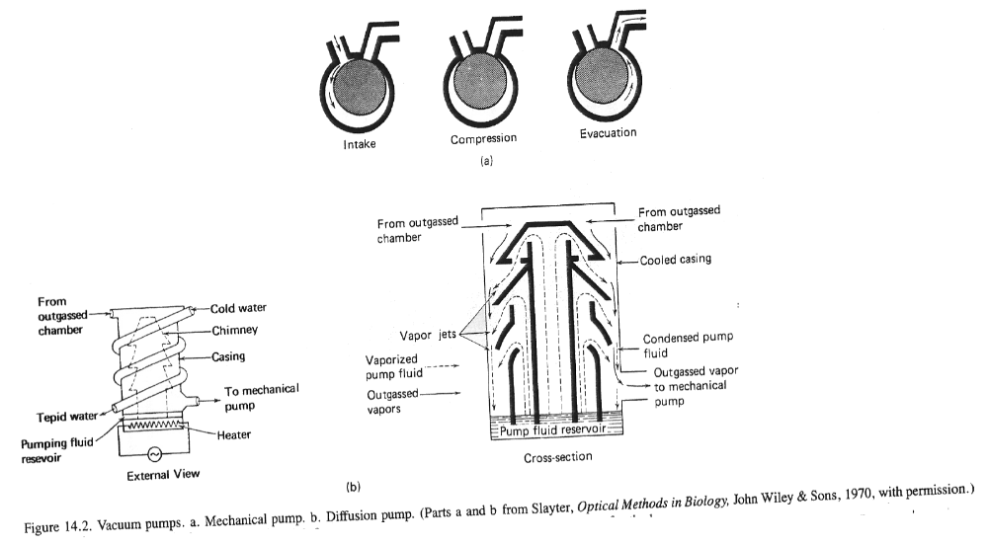

Parts of SEM. Find all of the parts of the SEM listed above. Open the specimen chamber door (as described below) to see the parts that are inside.
Inserting a Specimen
Venting the Specimen Chamber. Before the specimen chamber can be opened to atmosphere for inserting a new specimen, the electron beam must be shut off, the filament allowed to cool for a few minutes and the “specimen change” or “vent” button must be activated. Once the specimen chamber has been vented with air (some microscopes such as the MU JSM7200 use dry nitrogen), a specimen may be inserted into the specimen stage. Note that many instruments (not the MU JSM5310) make use of a sample exchange airlock to minimize the volume which must be brought up to atmosphere while changing the specimen. Such a system preserves the vacuum in the specimen chamber itself and allows faster pump down and a maintains a cleaner chamber. In fact, a good vacuum is so important that anything placed in the evacuated areas of the microscope, including the specimen, should be handled only with lint-free gloves.
Conductive Specimens. During imaging, electrons are continually bombarding the specimen and would eventually build up a negative charge on areas of the specimen under the beam. This charge, if large enough, could deflect both incident and emitted electrons and create areas of very high signal (e-) thereby distorting the image. To prevent this effect most specimens must be electrically conductive so that the current injected into the specimen has a path to an electrical ground through the specimen stage. Metals are already conductive but ceramics, polymers, and biological materials are not. The usual remedy is to coat the specimen surface with a thin layer of a conducting substance such as gold-palladium or carbon in a sputter coating or evaporative coating device. In fact, for the highest-quality SEM images, all specimens (even metals!) should be coated. When imaging single digit nanometer scale features, be mindful of possible coating artefact-we can see the particles that comprise the coating. Ensure that a good conductive path exists from the coating on the specimen to ground by means of a path to the specimen stub made with conducting paint or conductive tape.

Specimen Stage. The stage holding the specimen is usually capable of tilt, elevation, and rotation motions in addition to x and y translations for changing the field of view. The specimen is often tilted about 30-45 toward the E-T detector to increase electron signal collection. Adjustment of the elevation or “z motion” is used to control the working distance, the distance from the bottom of objective lens to the specimen. Short working distances are used to achieve the best image resolution while long working distances improve depth-of-field and low magnification operation (see SEM Lab exercise 2). The rotation motion is useful for aligning features with a particular picture direction and for sequentially examining several specimens by rotating a turntable holding many specimen stubs. WHEN RAISING THE STAGE, BE CAREFUL, IT CAN COLIDE WITH THE DETECTORS. A foolproof solution to this problem is to raise the stage before closing the door and when the door is shut, to only lower it to the desired working distance.

Stage Motions. Insert the specimen on the stage and observe the effects of each stage motion. If signal is low, tilt the specimen toward E-T detector by 30.

Pumping the Specimen Chamber. Close the stage door and evacuate the specimen chamber by pressing the “evac” button. Wait 2-5 min for the “HT ready” light to come on, indicating that the vacuum is adequate for operation (HT means high-tension, another term for high-voltage).
  - Obtaining an Image
Step 1: Assuring Adequate Vacuum. Proper vacuum has been reached when the “HT ready” indication comes on the LCD; confirm that a line scanning raster is just visible on the viewing screen (select line scan button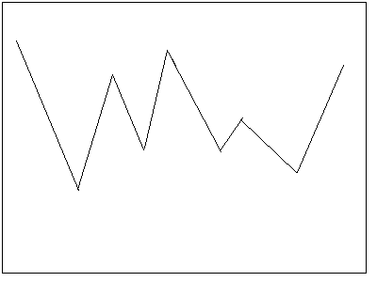, lower mag to under 1000x and raise brightness until line appears). When the HT button is depressed, the MU JSM5310 SEM automatically turns on the high voltage at the E-T detector PMT, and other amplifiers leading to the CRT display screen.

Step 2: Saturation of the Electron Gun. Three different types of electron sources are commonly encountered: the tungsten hairpin thermionic (most common, found in the JSM5310), LaB₆ (thermionic), and field emission (more costly, found in the MU JSM7200). Each source requires a different procedure for proper operation. For a tungsten hairpin, turn on the filament heating circuit and raise the filament-heating knob until the intensity on the viewing screen begins to increase. Observe the effect of this increase on the screen as the line rises (brighter) and becomes jagged (more contrast). This line is simply a one dimensional line scan (x) plotted against intensity (y). With a conventional tungsten filament you will observe an increase in beam intensity (line raises) followed by a drop of intensity (line drops); this is the “false peak” seen as you heat the filament. When the intensity does not increase further (line stops going up) with continued increases in filament heating, you have reached saturation and should back off slightly for operation. It is very important not to overheat the tungsten because this can cut the filament lifetime drastically. Normal tungsten filament life is 40-100 hrs, but lifetimes can be reduced to less than 10 hr if the filament heating is set too high. False peaks are evidence of e- emissions that arise from parts of the filament other than the tip.

Step 3: Contrast and Brightness. Now switch from line-scan to TV mode (press TV button 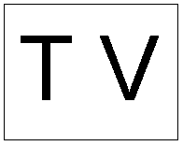 ) If an image is apparent on the screen, adjust the “contrast” control to obtain a pleasing contrast. Adjust the “brightness” control to bring the screen intensity to a suitable viewing level. These operations may have to be repeated after focusing.

What are the brigntness and contrast controls actually doing?

Step 4: Focusing the Image. The JEOL 5310LV has separate adjustments for “spot size” and “focus.” “Spot size,” the minimum possible size of the beam at the specimen, is controlled by the action of the condenser lens, which is the first lens below the electron gun. The smaller the spot (probe) size, the finer will be the detail which can be observed on a suitable specimen, which is generally a desirable goal. However, a serious consequence of reducing the spot size is that the beam current falls as the inverse square of the beam diameter. A lower beam current will result in a noisier image with poorer contrast sensitivity. Select a medium value for the spot size to obtain an adequate amount of current in a beam using “spot size” knob.

Note: Depending on the filament and gun alignment, sometimes larger spot sizes (16-24) require extensive realignment. To avoid this, on the JSM5310, we can simply use spot sizes 1-15 which are all useable without this realignment.

‘Focus’ is controlled by the action of the objective lens, which is the final lens in the column. Using the course focus buttons or fine control knob of the objective lens brings the image of the specimen into focus. Use the stage motions to find an area of interest.
Notice that the image may go out of focus in the new area. The image may be refocused using either the objective lens or the stage z-drive, careful not to go too far up with stage.

Step 5: Optimizing the Image. SEM images are subject to defects which degrade their quality and which become apparent at high magnification. Astigmatism is the most common defect encountered. To look for this defect, find an area of the specimen with fine random detail, switch to high magnification (10, 000 x or above), focus the image as well as possible. As you rotate the objective lens knob back and forth on either side of the focus position, notice whether the image appears to line up or stretch out in two orthogonal directions (90 apart). If this is the case, the image is astigmatic and will never come into sharp focus without astigmatic correction. Set the focus to a position midway between the stretched images where the image detail appears randomly oriented but still out of focus. Using only one stigmator control, sharpen the image, then refocus. Now stigmate with the other stigmator control, refocus, and repeat until a sharp image is obtained. Stigmating correctly takes some practice so do not be discouraged if your first picture is not perfect!

Step 6: Selecting the Magnifcation. Unlike practical use of light optical microscopes which require lens changes for magnification change, after the SEM image is focused at high magnification it is in near-perfect focus at all lower magnifications since the objective lens setting has not changed. High image magnifications in the SEM mean that the scan raster on the specimen is very small, but that the image information is magnified to the size of the viewing screen, photograph, or digital image. On the CRT, each phosphor element (pixel) of the screen is a small part of the scan. In a digital image captured with a computer, each pixel defined in the image file represents a discrete part of the overall scan. Select an image magnification of about 1000x.

If you scan at 1000x and your CRT screen is 10cm wide (in x), how wide (in x) is the scan range on you sample?

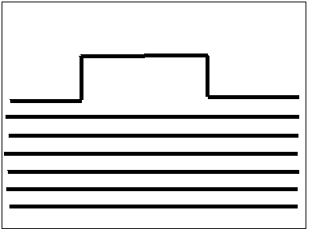Step 7: Capturing an image. Finally adjust the “contrast” and “brightness” at the viewing screen for proper photography conditions. On the JSM5310, This is done by pressing the button. A small image will appear on the screen as well as a tracing like the one below (this mode is also useful when focusing):
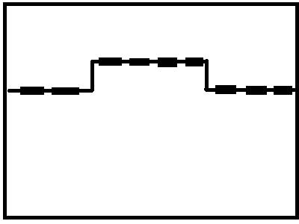 .

For best image, adjust contrast until 4 blocks are raised above the line and adjust brightness until these blocks are centered on the line. Using the capture board on the computer, capture an image using either slow or medium scan rate (see protocol on PRINTERFACE use).
Note: Do not change any visual or record parameters in Printerface.

1.4 Image Quality

The electron source brightness ultimately controls image quality. The beam current and the diameter are related by the brightness equation .

Brightness Beam Current / (beam area)(solid angle)
Solid angle is the convergence angle of the electron beam as it leaves the column and impacts the sample

Which controls change beam current? Beam area? Convergence angle?

One of the most important concepts in SEM is the relationship of the visibility of an object in the final image to the characteristics of the signal generated at the sample.

This relationship is defined by the threshold equation…

Threshold curr. 1____________________________________________
(collection efficiency of detector) (minimum detectable contrast level-property of sample) (frame time for full frame scan)

The threshold current is the minimum beam current needed to detect contrast between 2 parts of your sample.
We assume that collection efficiency and contrast level inherent to your sample are constant, this leaves beam current and scan rate under our control. Our goal is to adjust the beam current and scan rate until we can detect the differences we wish to see in our sample (i.e. contrast). What happens to the quantity of electrons absorbed by and emitted from the sample when you change either of these parameters?

Experiment 1.1: Effect of Beam Current on Image Quality.
At 5000x mag. or above, observe the high topography specimen at a spot size of 6, 12 , and 15. Look for the finest detail that can be seen for each beam current. By reducing the beam current we should get a smaller beam diameter and be able to see smaller details (higher resolution). Does this actually happen? How does feature visibility (contrast) vary with beam current ? (try spot size of 2 to really see the effect).
Using the threshold equation as a guide, how can you compensate for a low beam current (very small spot size) to still get enough signal for minimum visible contrast?

Experiment 1.2: Effect of Scan Rate on Image Quality. When we examine an unknown specimen in the SEM, we generally search at a rapid scan rate, 1 sec/frame or faster up to TV scan rate (0.03 sec/frame), but we photographically document the image at a much slower scan rate, typically 60-100 sec/frame. Obtain a series of images of the topographic sample at ~7,500x at 4 sec/frame (visual>midscan), and at 30 sec/frame (record>fastrec) with a low beam current of (SS <10 ~1nA). Compare the fine detail in the images. What strategy does this experiment suggest when seeking a very small feature of low contrast on the specimen?

For the following probe diameters, fill in the resulting probe current (and resulting relative necessary scan rate) to obtain images with acceptable contrast quality.

Necessary probe diameter needed to obtain required resolution: high res., medium res., low res. (ss3, ss8, ss15) | Resulting probe current (low, med, or high) | relative frame rate required to achieve adequate contrast  (fast, med, slow)
High res.- ss3
Medium res. - ss8

Low res. - ss15

Thus, for a given probe size (current) it is possible to maximize the signal generated by adjusting dwell time of the beam (frame rate).

If the digital image generated by using record > fastrec in printerface is 616 pixels/486 pixels (x/y), what is the length (in the x dimension) of the object represented by one pixel at magnification of 10000x? Assume the scan rate is constant (30 seconds/frame for fastrec) and the beam diameter is the same size as one pixel; how long does the beam dwell on the sample to produce signal represented by 1 pixel. During formation of this image, how many beam electrons are impacting the sample at each pixel location (assume beam current = .5 nA)

JEOL 5310LV cutaway view

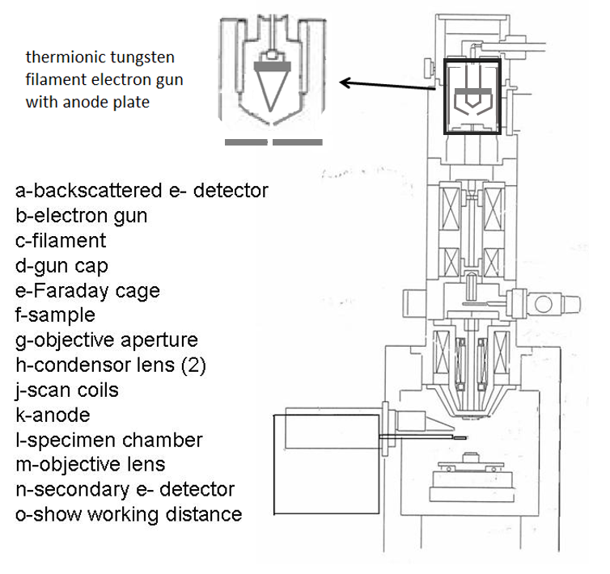

JEOL 5310LV outside view

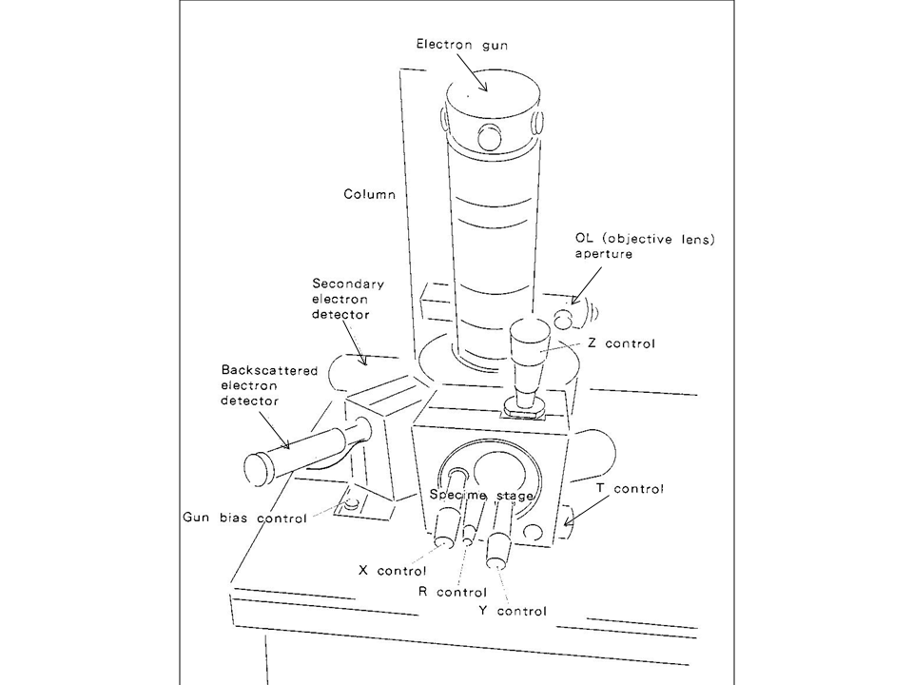

Discussion questions
-What are 2 basic ways to focus nearly any microscope?
- What are the brigntness and contrast controls actually doing?
-If you scan at 1000x and your CRT screen is 10cm wide (in x), how wide (in x) is the scan range on you sample?
-what happens if you negatively bias the Faraday cage?.
-Parts of SEM. Find all of the parts of the SEM listed above. Open the specimen chamber door (as described below) to see the parts that are inside.
-Which controls change beam current? Beam area? Convergence angle?
-If the digital image generated by using record > fastrec in printerface is 616 pixels x 486 pixels, what is the size on the object represented by one pixel at magnification of 10000x? Assume the scan rate is constant (30 seconds/frame for fastrec) and the beam diameter is the same size as one pixel (that would be a bit under-sampled); how long does the beam dwell on the sample to produce signal represented by 1 pixel.
During formation of this image, how many beam electrons are impacting the sample at each pixel location (assume probe current = .5 nA)
Do the same calculation with magnification at 1000x.
Do the same calculation with beam current 10nA.

