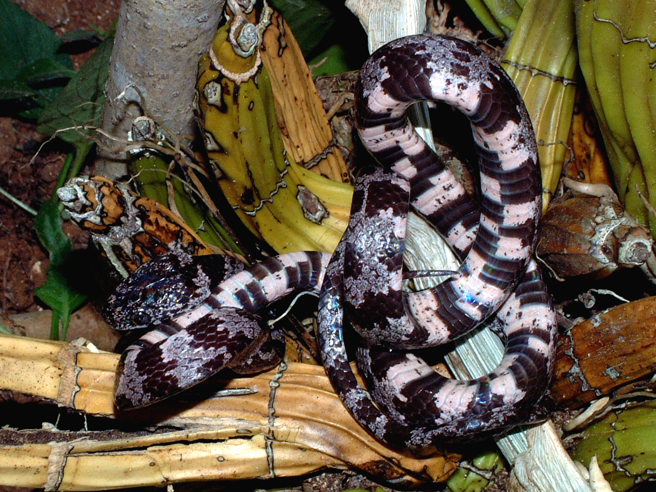

Common Name: Cloudy Snail Sucker Native Name:

Scientific Name: Sibon nebulata Family: Colubridae

Information: A tenuous, nocturnal snake that is relatively common throughout forests. Very inoffensive and not venomous. Normally an arboreal snake, but is usually found as it crawls on the ground between trees/shrubs. Feeds primarily on slugs and snails. Lays eggs.

Descriptive Characteristics: Slender, large eyes, max length Key Characteristics:
about 1 m. Smooth scales
Black and Gray bands

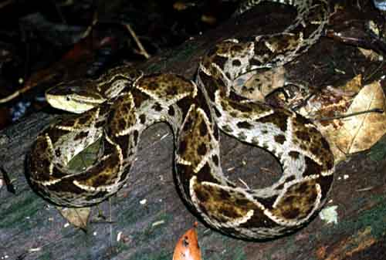
eco.ib.usp.br/.../imagens/ Bothrops%20asper%2002.JPG

Common Name: Terciopelo, Fer-de-lance Native Name:

Scientific Name: Bothrops asper (atrox) Family: Viperidae

Information: A large, defensive snake that is highly venomous. It can be found in almost any habitat searching for food. Natives fear the bite of this snake more than any other, and with good reason. It delivers a potent hemotoxin that is more than capable of killing an adult human. Ovoviviparous.

Descriptive Characteristics: Large, triangular head, Key Characteristics:
loreal pit, up to 2.5 m Keeled scales
Dark stripe behind eye
15 or more scale rows

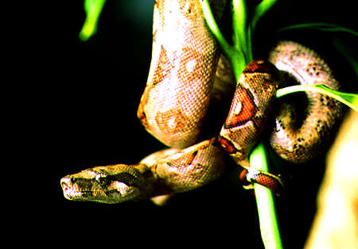
http://www.belizezoo.org/zoo/zoo/herps/boa/boa2.html

Common Name: Red-tailed Boa Constrictor Native Name:

Scientific Name: Boa constrictor Family: Boidae

Information: A large, heavy bodied snake that kills it prey by constricting. Found in forests where it is both terrestrial and arboreal. Has modified scales above the mouth that sense IR heat. May inflict a painful bite if grasped, but it is not venomous. Gives birth to live young.

Descriptive Characteristics: Heavy bodied, chain-like pattern Key Characteristics:
present on back. Up to 3 m in length. Smooth scales
Tan to dark brown
30 or more scale rows

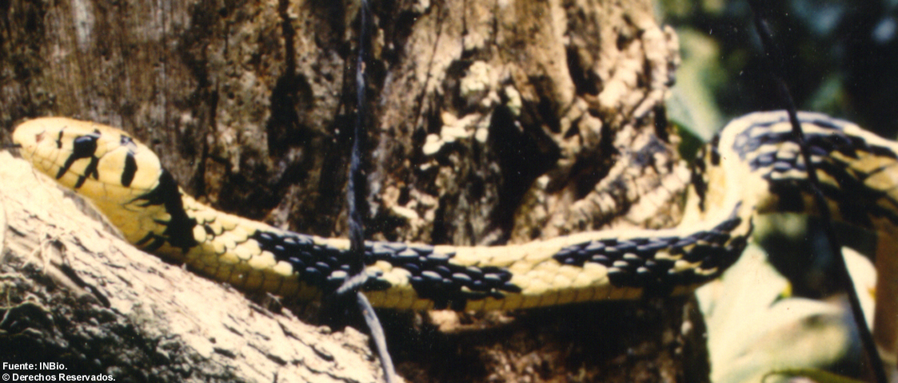
http://www.inbio.ac.cr/bims/ubi/reptiles/ubiespejo/ubiid=3960&-find.html

Common Name: Neotropical Rat Snake Native Name:

Scientific Name: Spilotes pullatus Family: Colubridae

Information: A slender, diurnal snake that is very active. When threatened, they flee at first, but will puff out their neck and bite if provoked. Found in a wide range of habitats.

Descriptive Characteristics: Slender, large round eyes, Key Characteristics:
Max. length about 2 m. Smooth scales
Black and yellow
Approx.18 scale rows

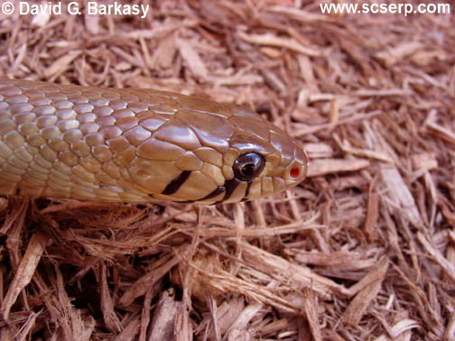

Common Name: C.A. Indigo Snake Native Name:

Scientific Name: Drymarchon corais Family: Colubridae

Information: A medium bodied diurnal snake that will flee when approached, but will bite if provoked. Non-venomous. Lays eggs.

Descriptive Characteristics: Lines from eye to jaw. Max Key Characteristics:
length about 2 m. Body brown except for black tail. Smooth scales
Single anal plate
Brown with black tail
17 scale rows

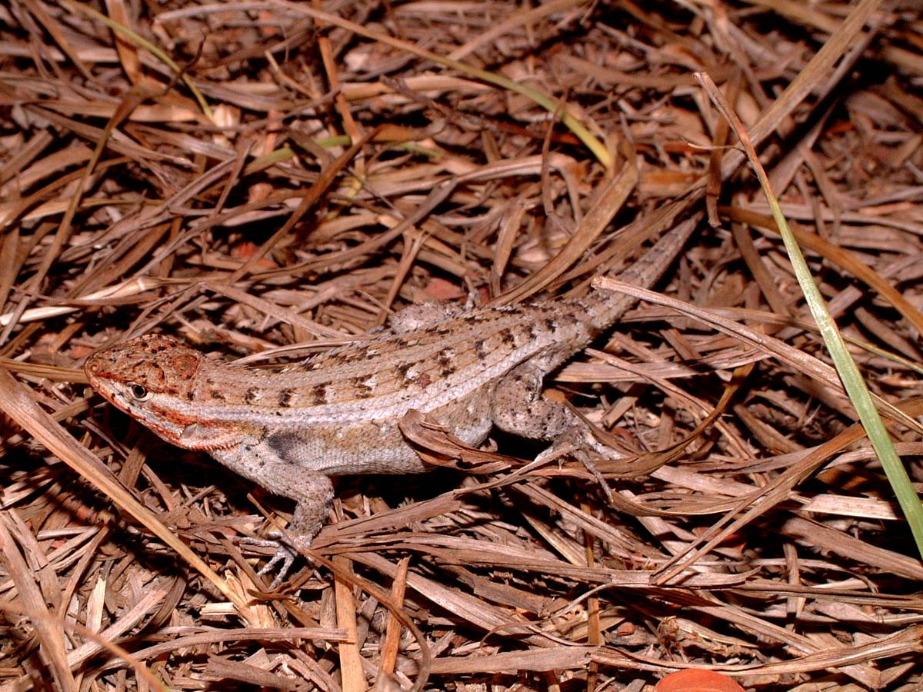

Common Name: Lundell’s Spiny Lizard Native Name:

Scientific Name: Sceloporus lundelli Family: Phrynosomatidae

Information: A heavy bodied, fast lizard that is active during hot days. Prefers disturbed habitats. Diurnal.

Descriptive Characteristics: Females are less colorful than Key Characteristics:
males. Both have a chevron pattern down their back Chevron pattern
Active during intense
temperatures

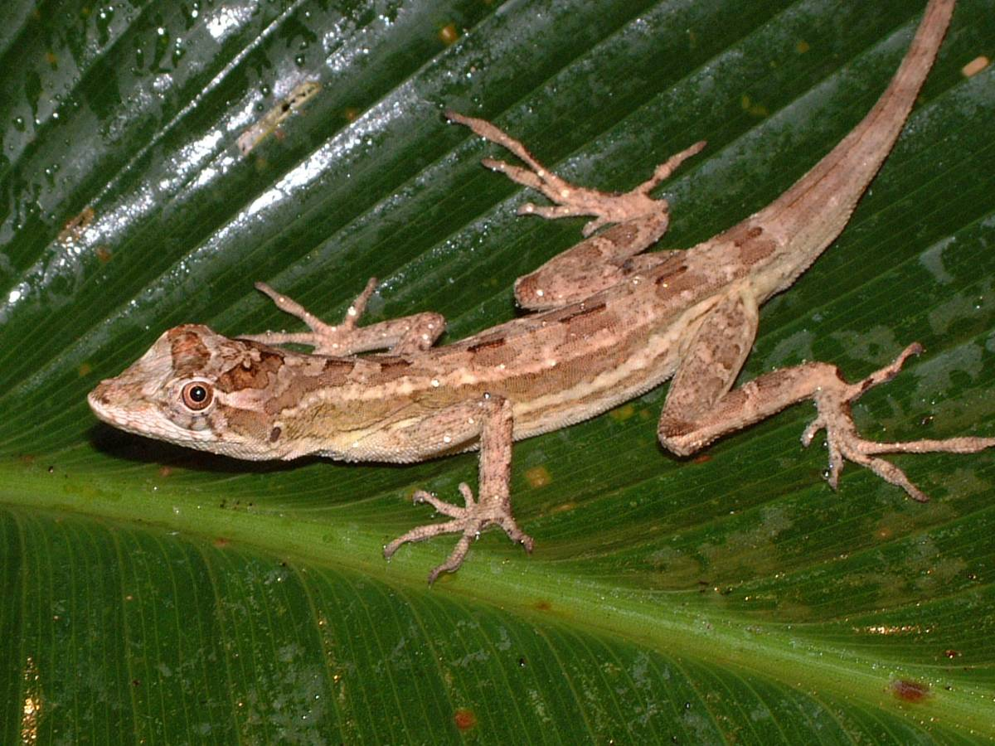

Common Name: Ghost Anole Native Name:

Scientific Name: Norops lemurinus Family: Polychrotidae

Information: A slender, diurnal lizard that prefers forest habitat.

Descriptive Characteristics: Males and females have Key Characteristics:
Contrasting patterns, with the males reaching a Orange/red dewlap
bulkier build than the female.

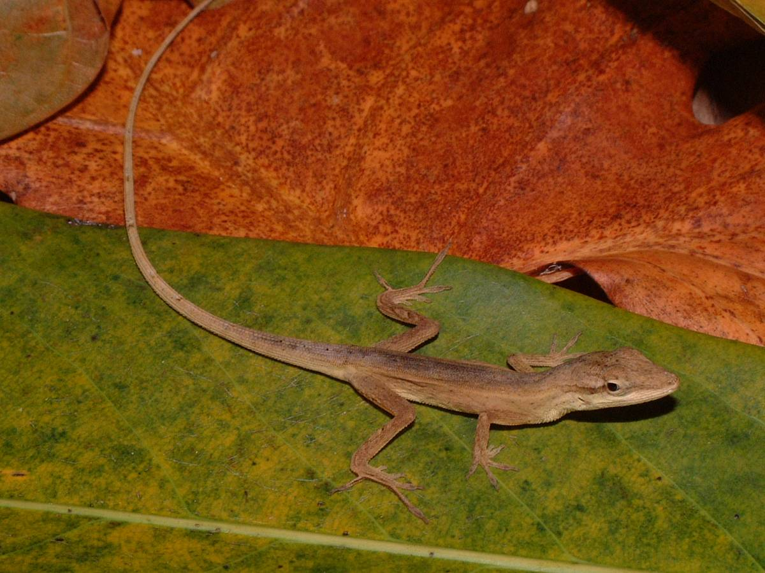

Common Name: Silky Anole (female) Native Name:

Scientific Name: Norops sericeus Family: Polychrotidae

Information: A slender, diurnal lizard that prefers disturbed habitat.

Descriptive Characteristics: Females normally have a light Key Characteristics:
line down their back. Both sexes have an orange/yellow Blue-spotted dewlap
dewlap with a central spot.

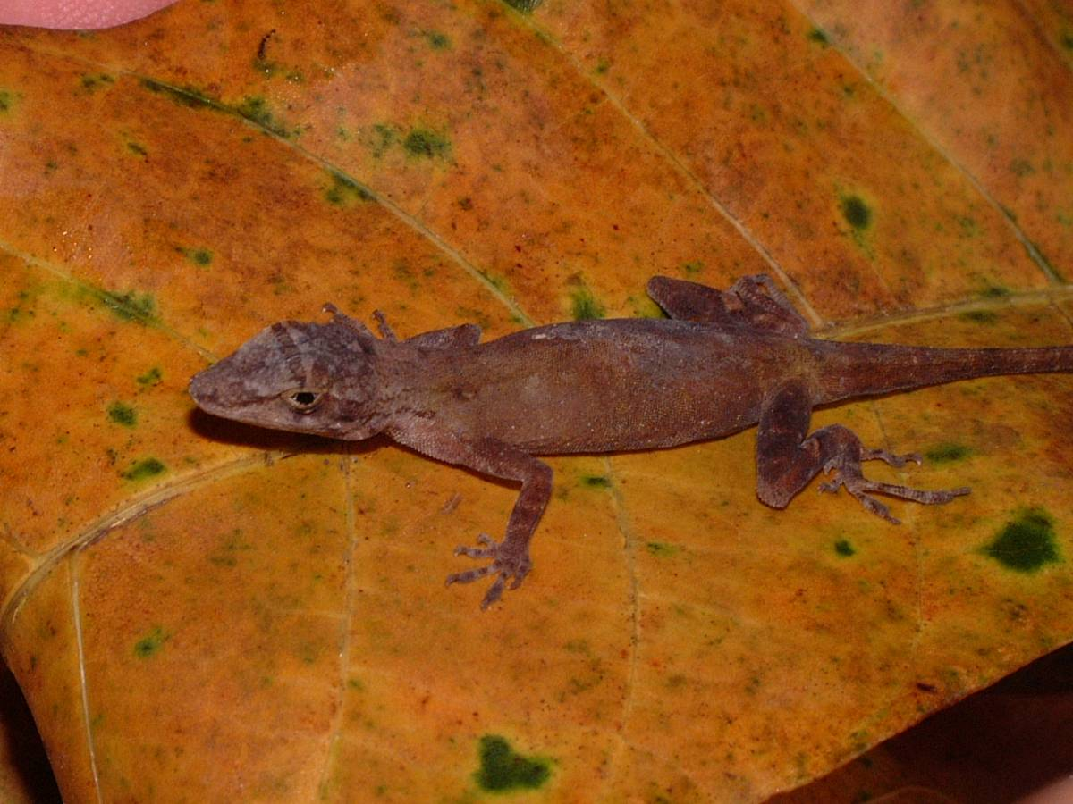

Common Name: Smooth Anole Native Name:

Scientific Name: Norops rodriguezii Family: Polychrotidae

Information: A slender, diurnal lizard that prefers disturbed habitat.

Descriptive Characteristics: A brownish anole with slender Key Characteristics:
legs and expanded toe pads. Males have a pale yellow dewlap. Belly scales smooth
Both sexes usually have a bar between their eyes.

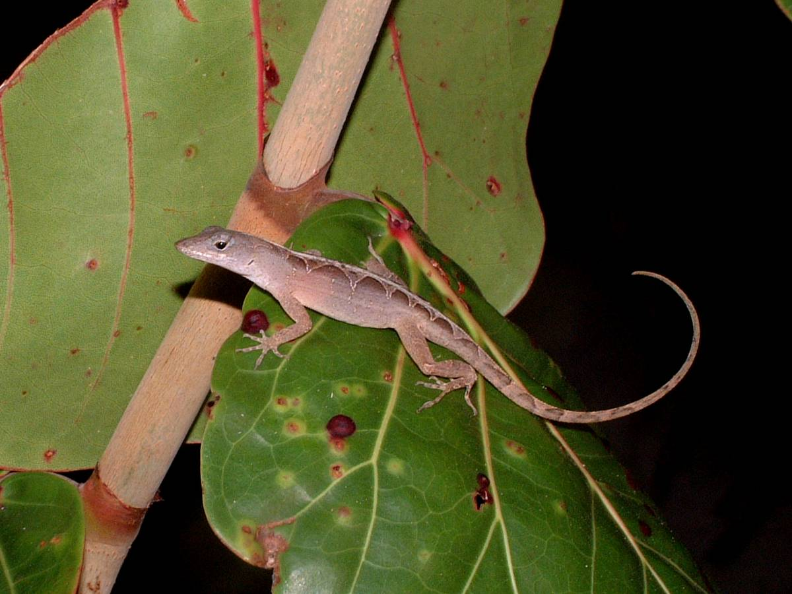

Common Name: Brown Anole Native Name:

Scientific Name: Norops sagrei Family: Polychrotidae

Information: A slender, diurnal lizard that prefers disturbed habitat. Usually is found in lower elevations and is common near the coast and on cayes.

Descriptive Characteristics: A brownish anole with an Key Characteristics:
hourglass pattern down their back. The color can vary Laterally compressed
greatly, from brown to black. They are the only anole species tail
that has a triangular tail instead of a circular one.

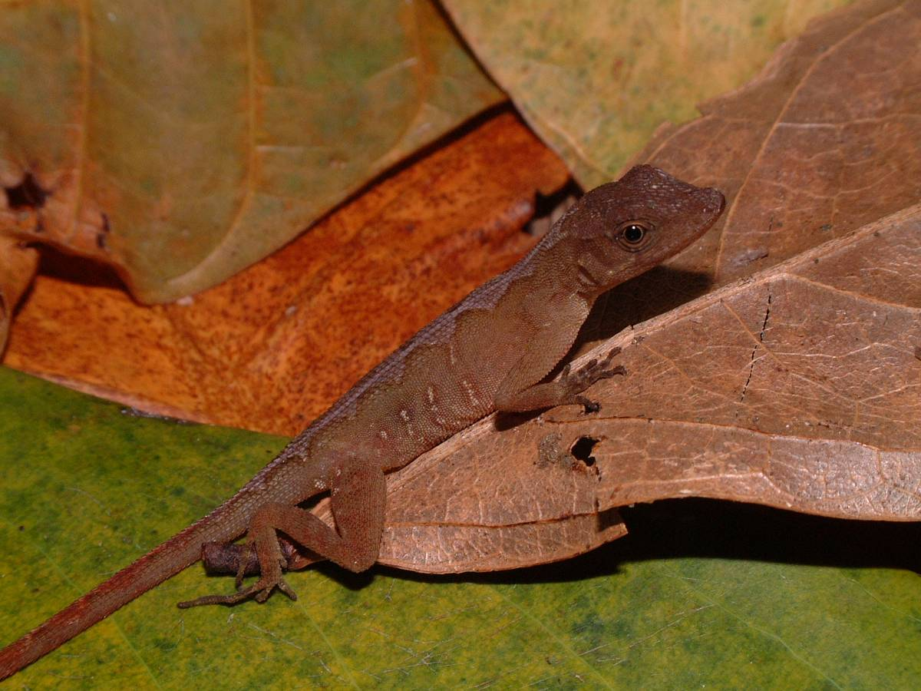

Common Name: Lesser Scaly Anole Native Name:

Scientific Name: Norops uniformus Family: Polychrotidae

Information: A slender, diurnal lizard that prefers undisturbed forest habitat. Frequently terrestrial.

Descriptive Characteristics: A brownish anole with a wavy Key Characteristics:
Middorsal stripe and small outlined vertical lines on the side of Large central belly smoothits body. Males have a reddish dewlap with a blue spot. scales and all belly
scales are keeled.

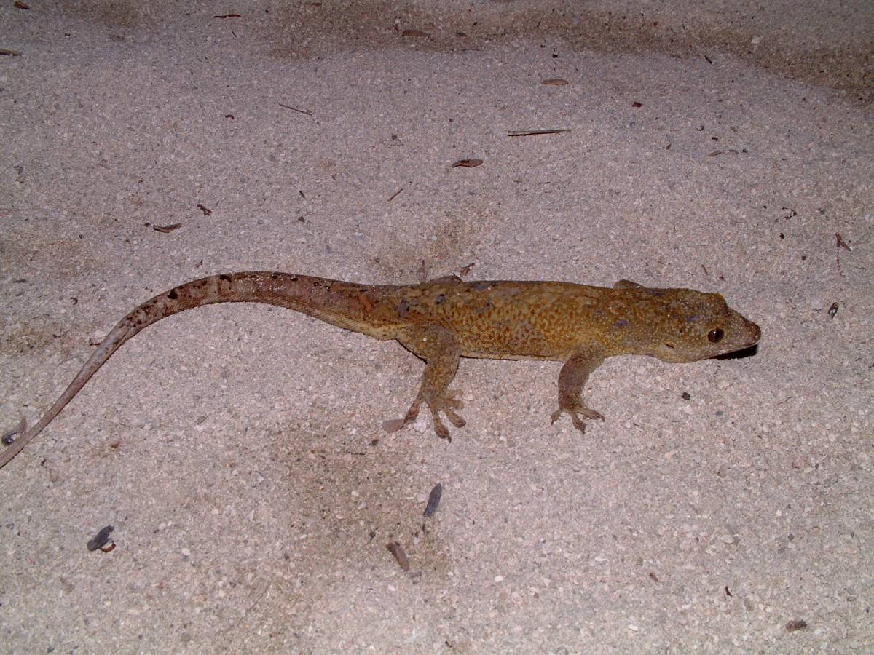

Common Name: Saint George’s Island Gecko Native Name:

Scientific Name: Aristelliger georgeensis Family: Gekkonidae

Information: A large, nocturnal lizard that grows to almost 10 inches. They are restricted to the coast and cayes.

Descriptive Characteristics: Normally, a reticulated pattern Key Characteristics:
exists down their back and white spots. Possibly confused with Large, range, toes
the Turnip Tail Gecko (Thecadactylus rapicauda) but is easily
differentiated by looking at the underside of the toes. The Turnip
Tail has a split down the middle while the Saint George’s does
not.

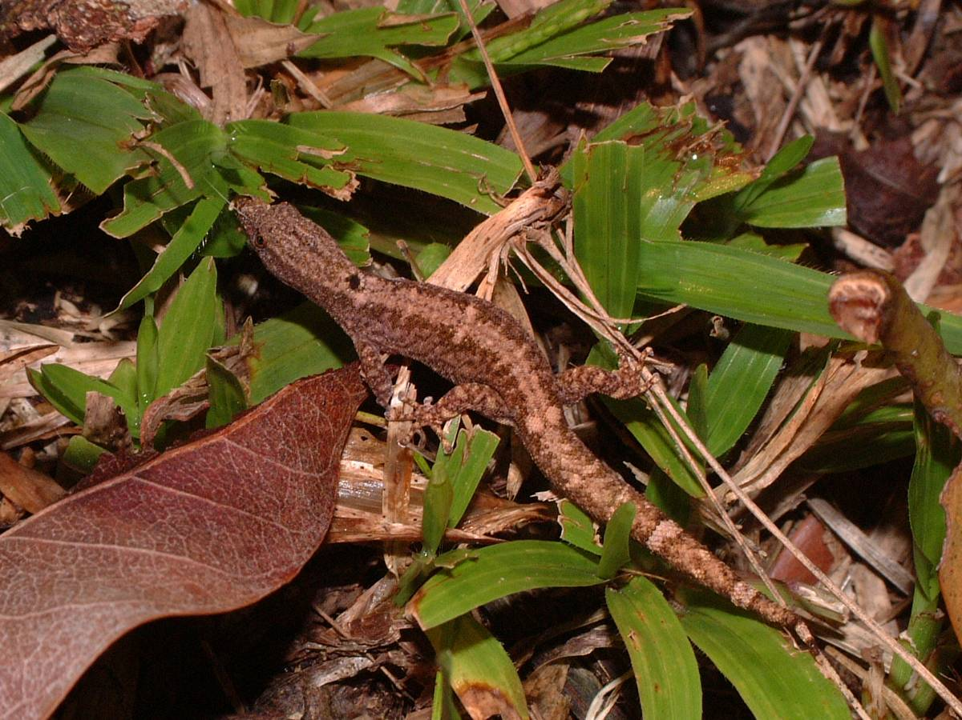

Common Name: Dwarf Gecko Native Name:

Scientific Name: Sphaerodactylus glaucus Family: Gekkonidae

Information: A minute, crepuscular lizard that may be active during the day. One of the smallest lizards in the world, adults are only about 4 cm. A very inoffensive lizard that is rather daring around humans, venturing into full sight and not fleeing. May autotomize its tail if bothered.

Descriptive Characteristics: Specimens have a thicker tail Key Characteristics:
than would be expected. Tiny size. Two white dots around Spot pairs
shoulders and hips.

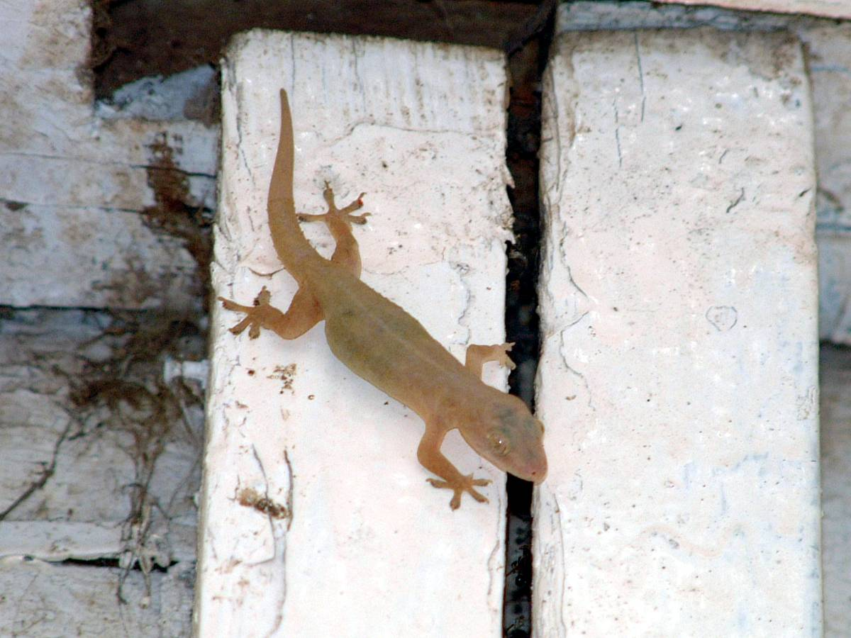

Common Name: House Gecko Native Name:

Scientific Name: Hemidactylus frenatus Family: Gekkonidae

Information: A medium built, drab colored gecko that is particularly abundant around buildings. An introduced species that naturally occurs in Asia/Indonesia. Almost fearless around humans. May autotomize its tail if bothered.

Descriptive Characteristics: Specimens have a flattened tail Key Characteristics:
that may have small tubercles protruding from it. Reaches about Drab colored
8 cm. in length.
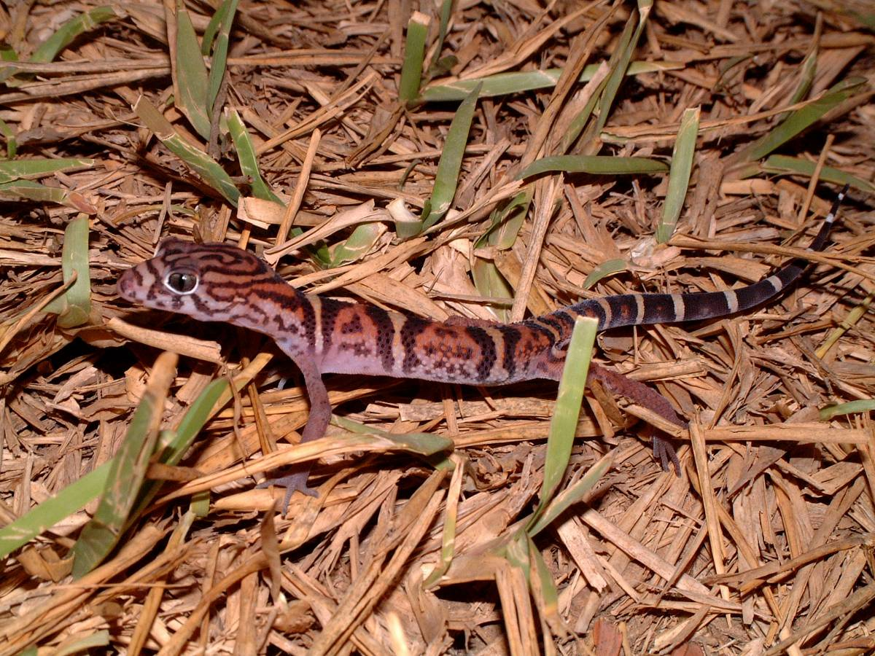

Common Name: C.A. Banded Gecko Native Name:

Scientific Name: Coleonyx elegens Family: Eublepharidae

Information: A slender, nocturnal lizard that carries itself higher off the ground than other geckos. May nip when first bothered, but quickly calms down when handled. Prefers open habitats with rocks to hide under. May autotomize its tail if bothered.

Descriptive Characteristics: Females and males are very Key Characteristics:
similar, except that males have a distinct set of femoral pores. Terrestrial
Distinct bands
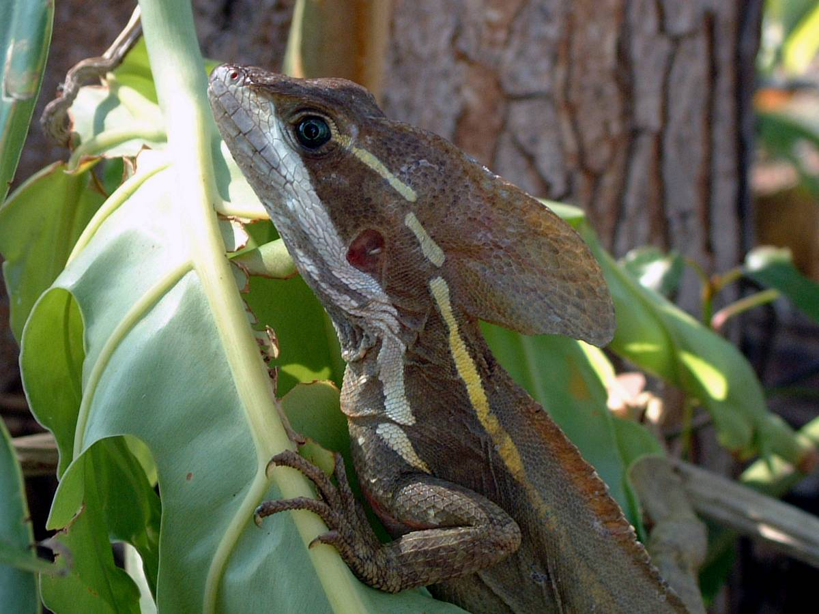

Common Name: Brown Basilisk Native Name:

Scientific Name: Basiliscus vittatus Family: Corytophanidae

Information: A medium-bodied diurnal lizard that will run on two legs when approached. Prefers disturbed habitats. Perches on vegetation at night where it sleeps vertically. Juveniles may run on the water, but this behavior is probably reserved for their close relative the Plumed Basilisk, Basiliscus plumifrons.

Descriptive Characteristics: Both sexes have two yellow lines Key Characteristics:
extending dorso-laterally down their back. Males have a large Dual yellow lines crest behind their heads. Females have a smaller version. on back

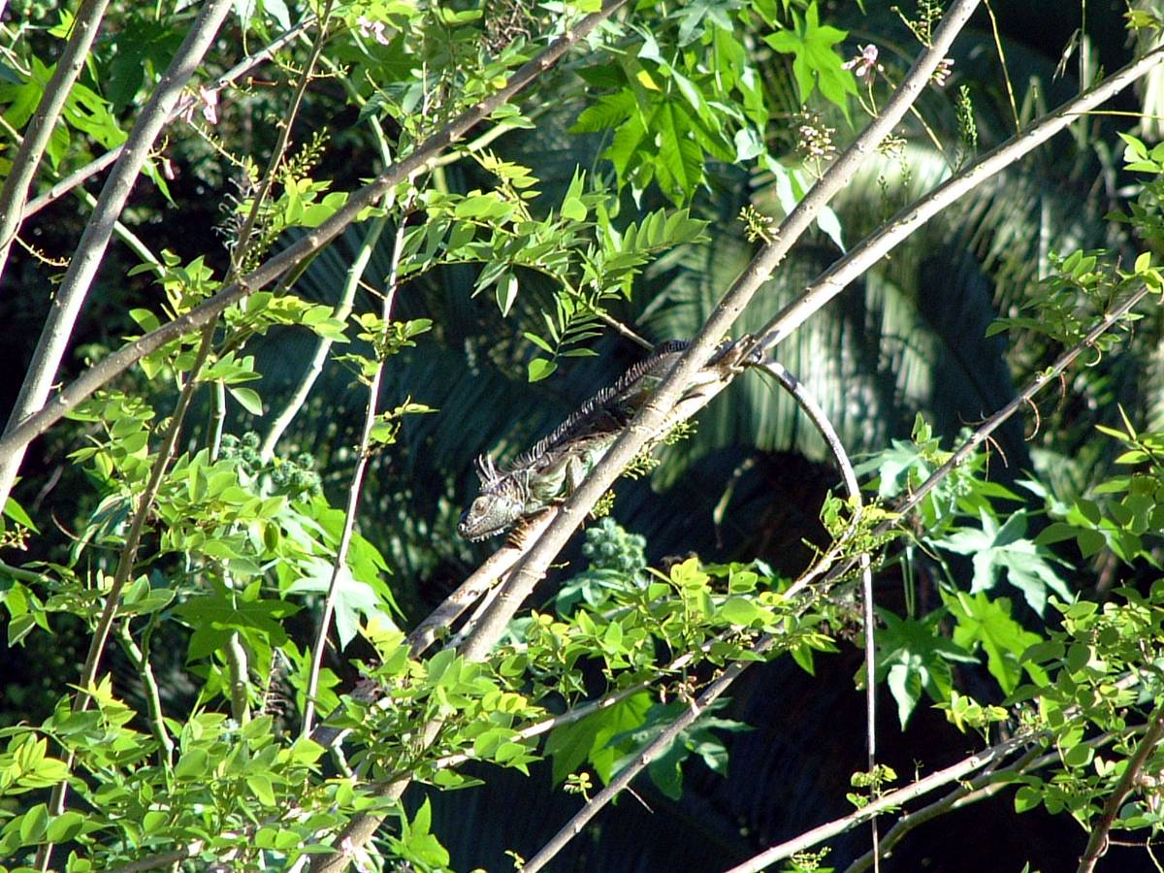

Common Name: Green Iguana Native Name:

Scientific Name: Iguana iguana Family: Iguanidae

Information: A large, diurnal lizard that is arboreal. Lays eggs and is a vegetarian. If grabbed, may bite and whip with their tail. Tail may be autotomized, especially when younger. When this happens, the regrowth is usually solid black.

Descriptive Characteristics: Males reach a larger size than Key Characteristics:
females and also have larger spikes protruding from their back. Green and brown
Commonly reach 2 m in length. Large Excellent swimmers

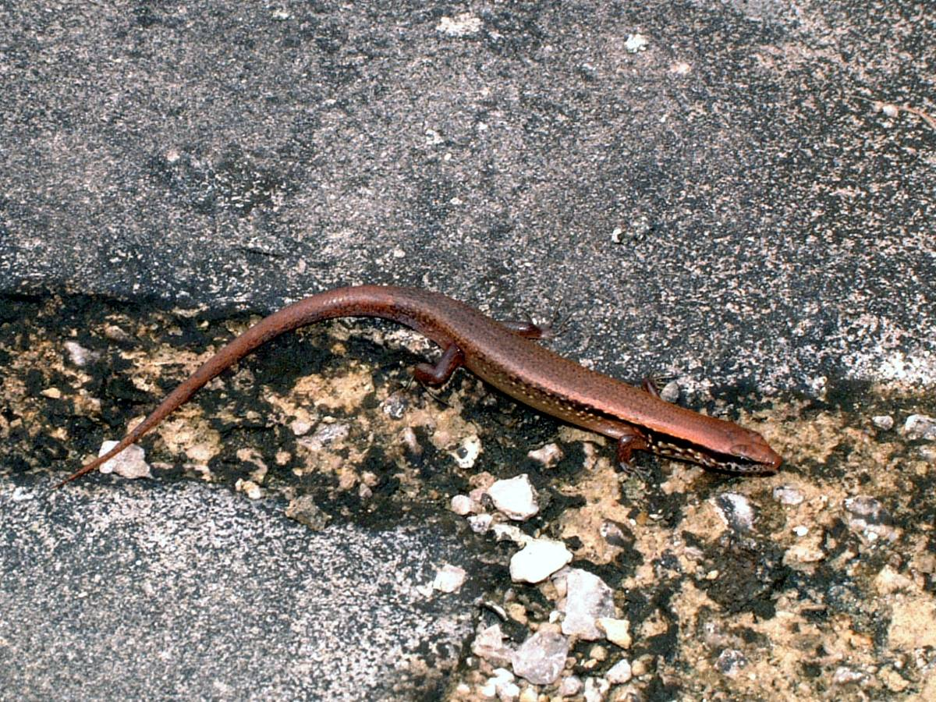

Common Name: Brown Forest Skink Native Name:

Scientific Name: Shenomorphus cherriei Family: Scincidae

Information: A small lizard that prefer open areas. Terrestrial and diurnal.

Descriptive Characteristics: Brown with a tan belly and Key Characteristics:
dark lines that start at the nose and fade out about halfway Spots on sides, brown
between the front and back legs.

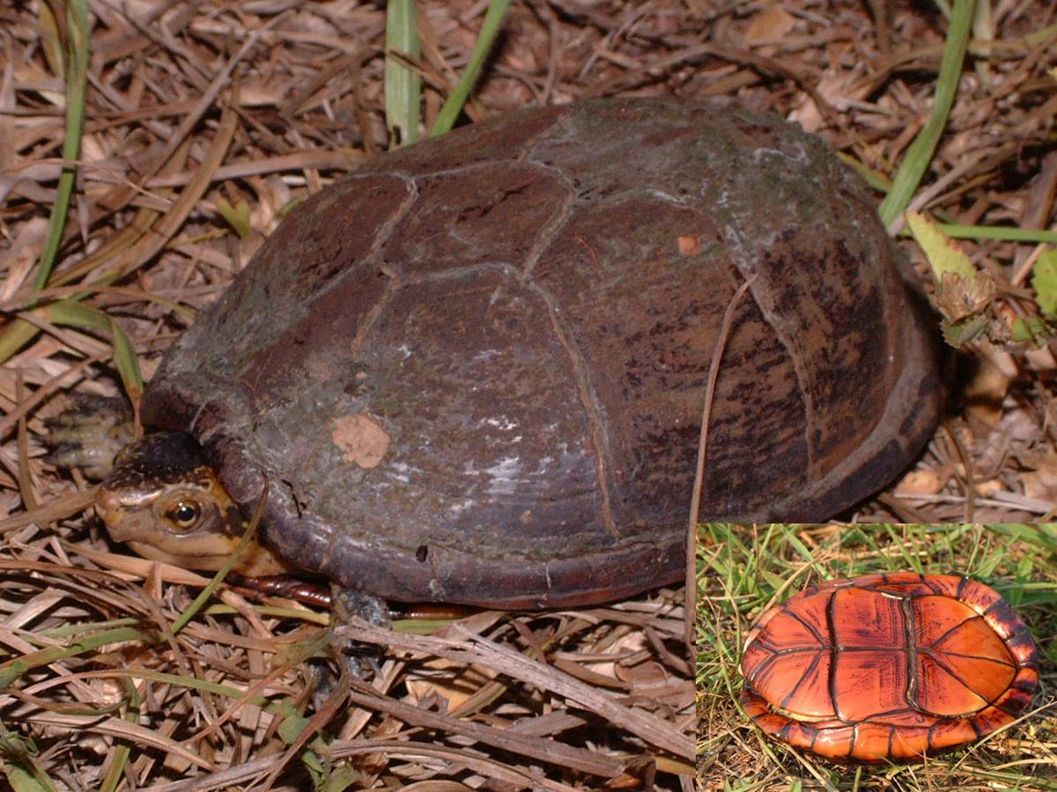

Common Name: White-lipped Mud Turtle Native Name:

Scientific Name: Kinosternum leucostomum Family: Kinosternidae

Information: Inhabitant of small, ephemeral pools. Can be found terrestrially during the dry season.

Descriptive Characteristics: Able to totally close itself inside Key Characteristics:
its shell. The male has a longer tail than the female. Plastron pattern

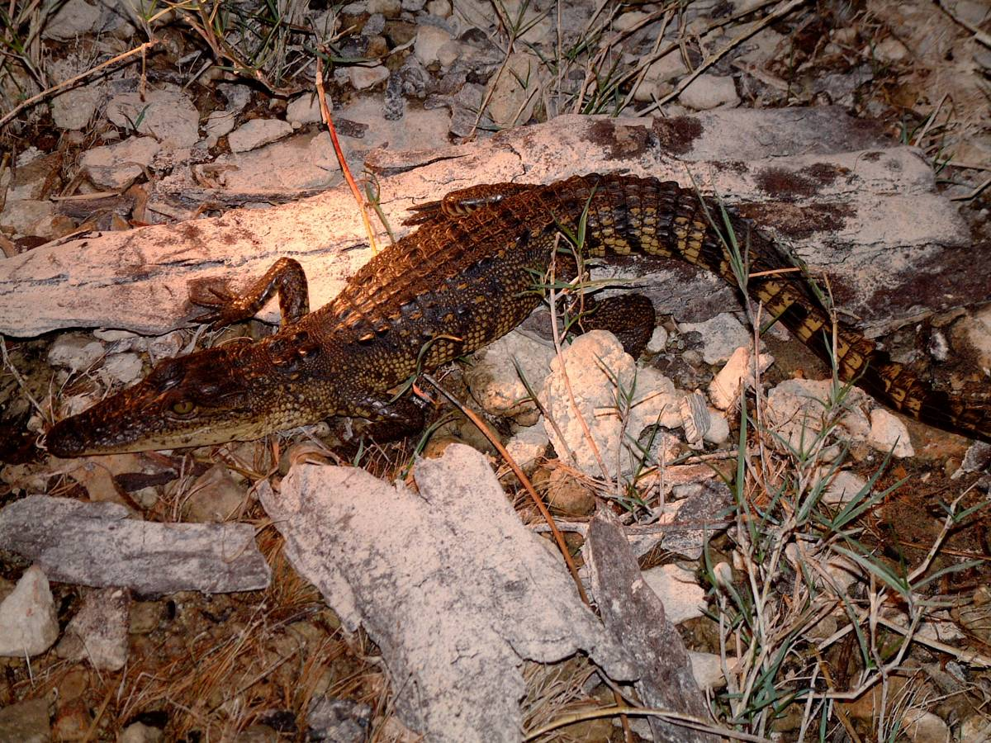

Common Name: Morellette’s Crocodile Native Name:

Scientific Name: Crocodylus morelletti Family: Crocodylia

Information: Inhabitant of inland streams, lakes, or just about any pool of water. Grows to almost 3 m, but is relatively harmless towards humans. Juveniles double in length within a year. Adults eyes shine cherry red, while juveniles shine a lighter, rose color.

Descriptive Characteristics: Dark brown with intermittent Key Characteristics:
patches of yellow. Distribution

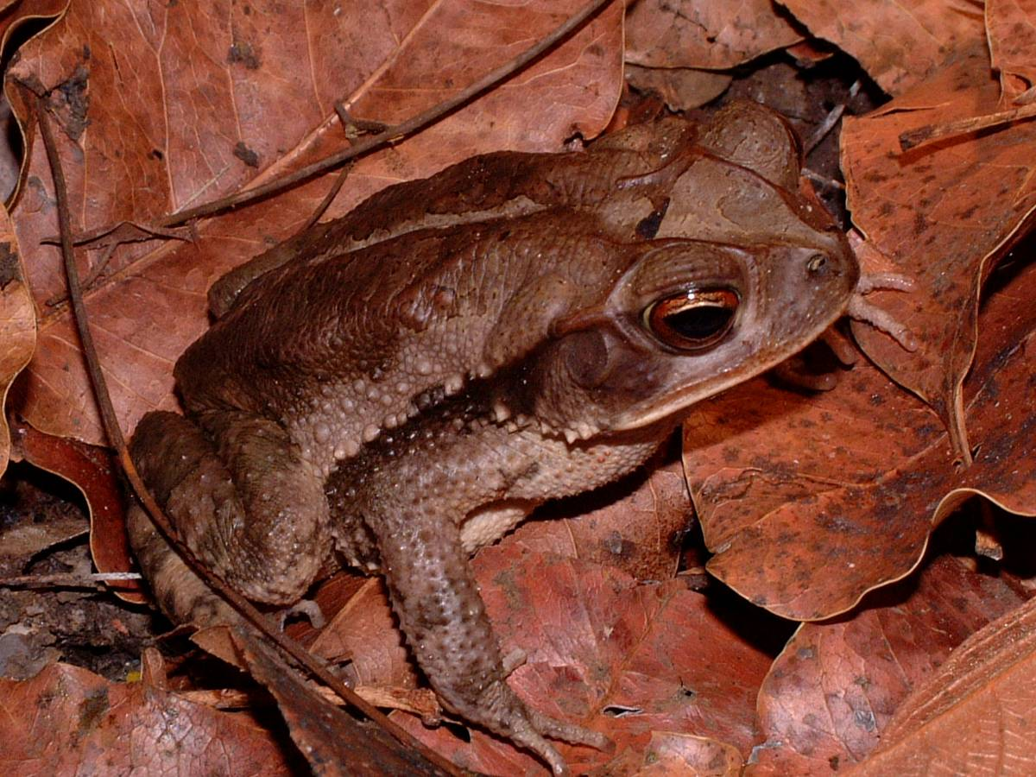

Common Name: Campbell’s Rainforest Toad Native Name:

Scientific Name: Bufo campbelli Family: Bufonidae

Information: Inhabitant of forested habitat.

Descriptive Characteristics: Has a small parotoid gland and Key Characteristics:
a smoother back than other toads. Black stripe on side
Low cranial ridges

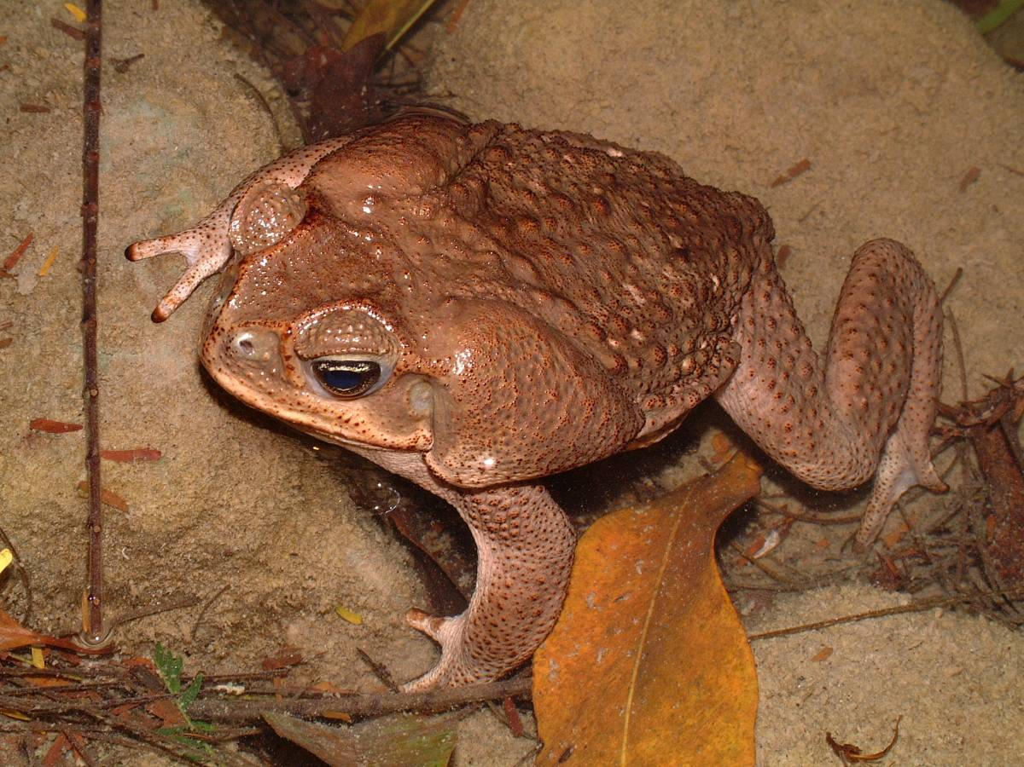

Common Name: Marine Toad Native Name:

Scientific Name: Bufo marinus Family: Bufonidae

Information: A large, abundant toad that prefers disturbed habitats. Extremely prolific, may lay 10,000 eggs in a single season. Boldly hops about in the open as if it has nothing to fear in life. Licking this toad will only give you high blood-pressure and a stomach ache, so refrain from the urge.

Descriptive Characteristics: Grows to a much larger size than Key Characteristics:
the other toads. Also lacks the dark stripe down the side of the Huge parotoid glands
body. Females reach a much larger size than males. Large size

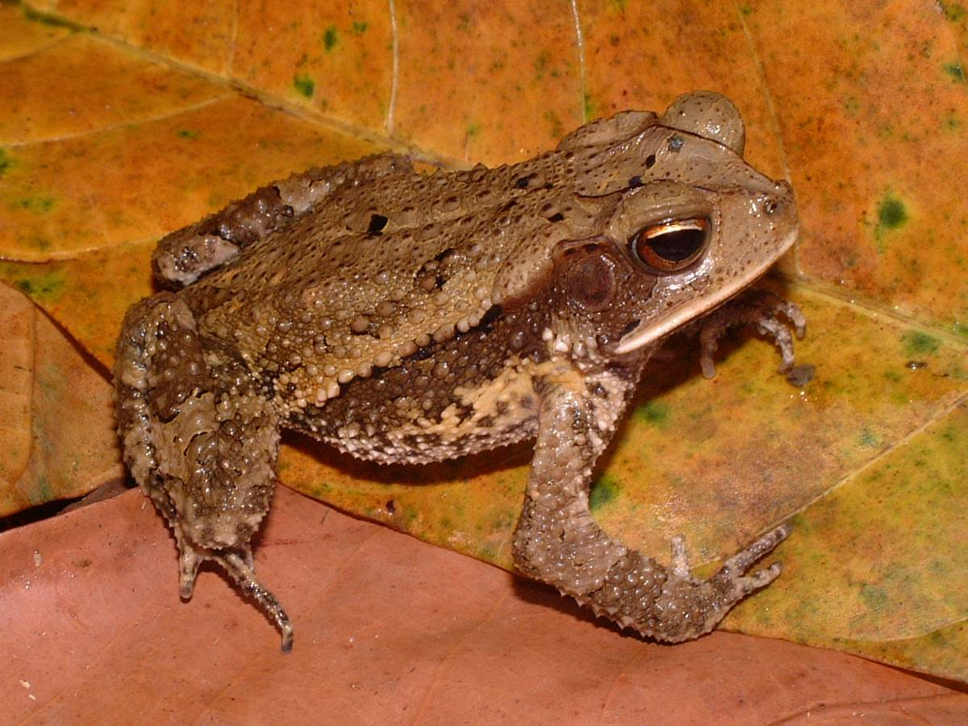

Common Name: Gulf Coast Toad Native Name:

Scientific Name: Bufo valliceps Family: Bufonidae

Information: A medium sized, abundant toad that prefers open, disturbed areas.

Descriptive Characteristics: Looks similar to Cambell’s Key Characteristics:
Toad, but there are subtle differences. They occupy different Dorsolateral Pattern
habitats, and the cranial crests are much larger in Bufo valliceps. Large cranial ridges

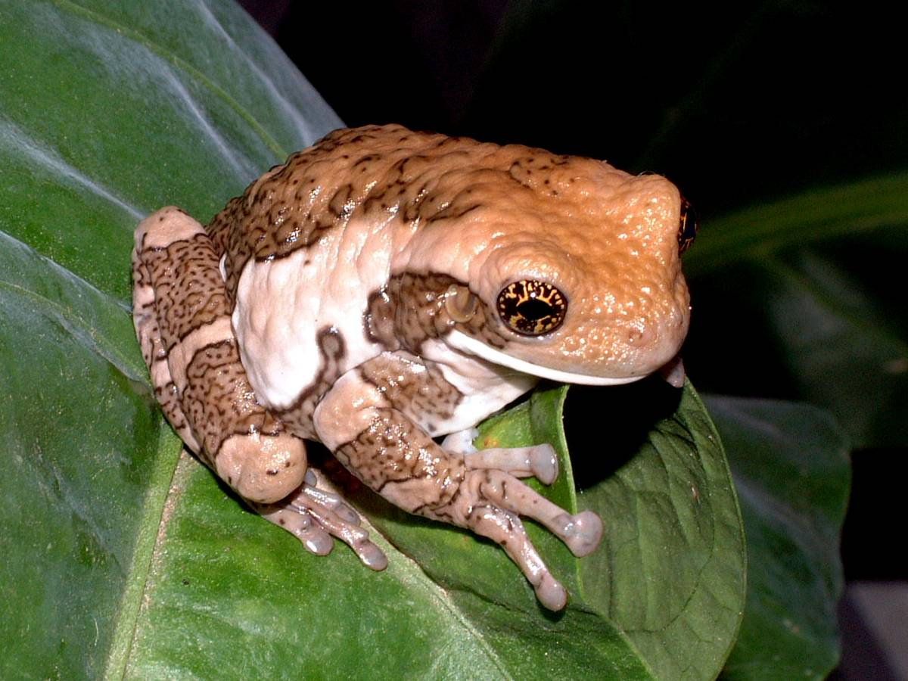

Common Name: Milky Treefrog; Veined Treefrog Native Name:

Scientific Name: Phrynohyas venulosa Family: Hylidae

Information: A large, arboreal frog that is quite scansorial despite its bulk. A beautiful frog to look at, but a mistake to touch. Do not try to grab it unless you want a viscous slime all over your hands. Is most frequently found on the walls of homes. It is best to simply allow the frog to sit on you than to try to restrain it.

Descriptive Characteristics: Does not look like any of the Key Characteristics:
other frogs, but is most easily recognized from its large size. Large size Slimy residue

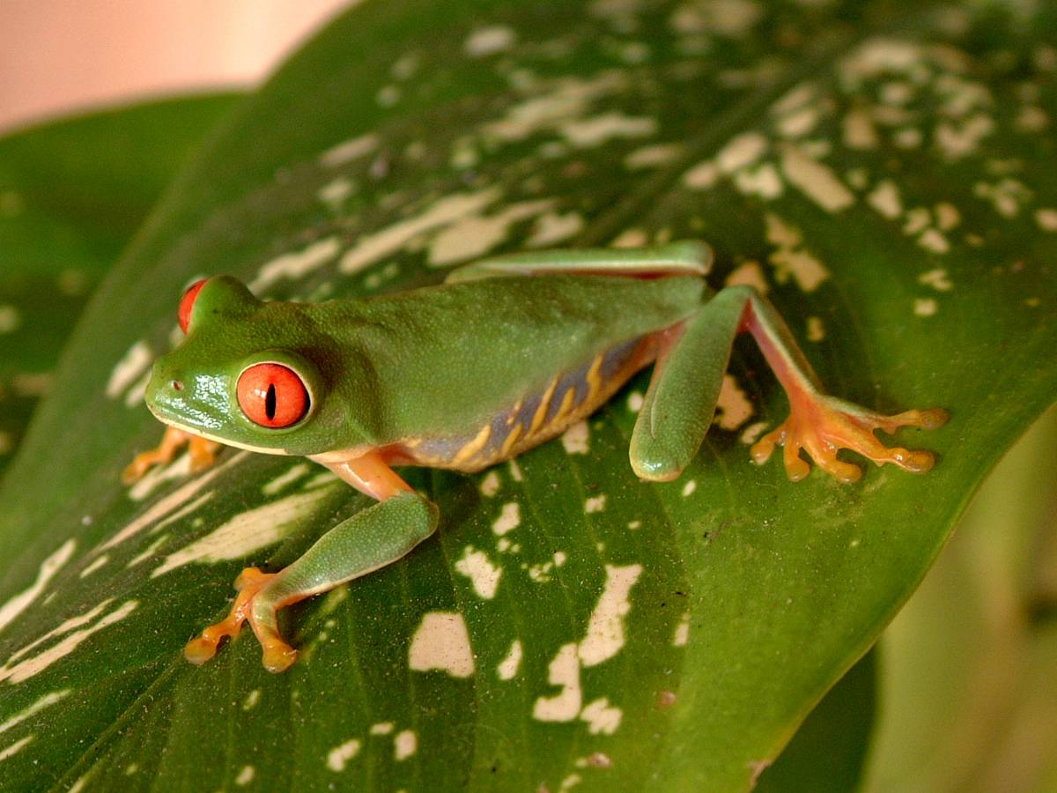

Common Name: Red-eyed Treefrog Native Name:

Scientific Name: Agalychnis calidryas Family: Hylidae

Information: A beautiful frog that prefers to walk instead of jumping. Most commonly found near ponds, swamps, or puddles in dense forest. Plasters itself to leaves during the day, completely concealing all colors except green. Lays its eggs on leaves overhanging the water.

Descriptive Characteristics: There is a similar species found Key Characteristics:
in Belize (Agalychnis morelletti), but it occurs only in the South. Red eyes
This species also has yellow bars through the blue stripes on its Orange feet
side. Females attain a larger body size than males

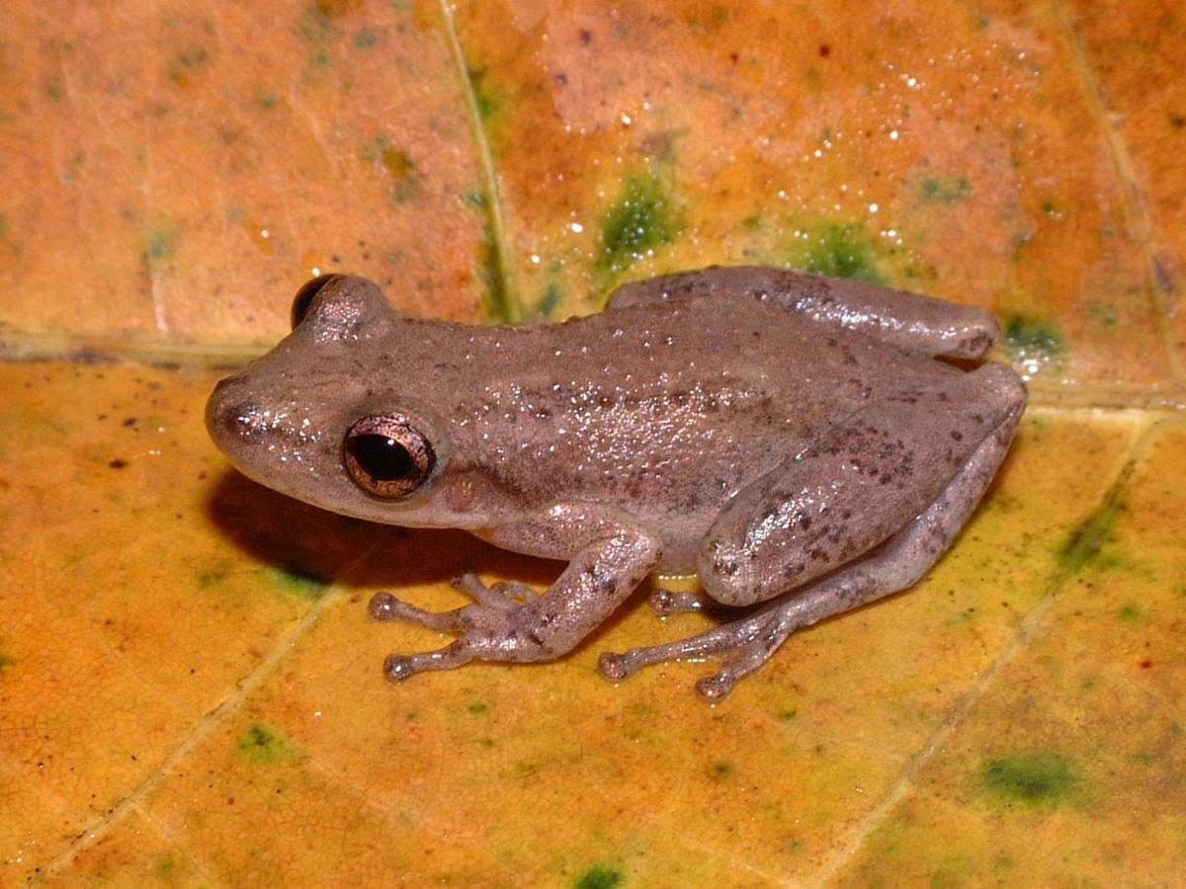

Common Name: Stauffer’s Treefrog Native Name:

Scientific Name: Scinax staufferi Family: Hylidae

Information: A small, arboreal frog that prefers disturbed habitats. A common frog that is normally found in shrubs or grasses.

Descriptive Characteristics: Brown frog with a few Key Characteristics:
longitudinal dark bars down back. Can range from tan Overbite
to dark brown colored. Dark spot between eyes

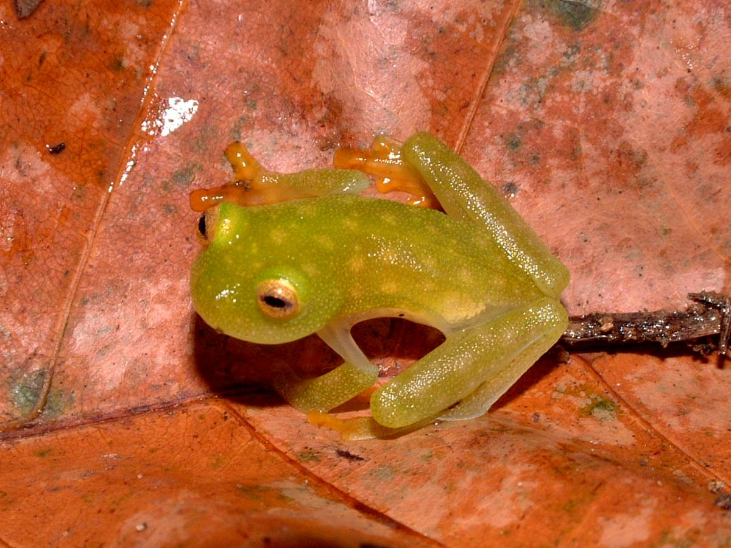

Common Name: Northern Glassfrog Native Name:

Scientific Name: Hyalinobatrachium fleischmanni Family: Centrolenidae

Information: A small, arboreal frog is associated with humid undisturbed forests. Usually found at night after a good rain. Named so because the organs are visible through the venter.

Descriptive Characteristics: Light green with yellow spots. Key Characteristics:
Usually small, 1 inch or less. See-through belly

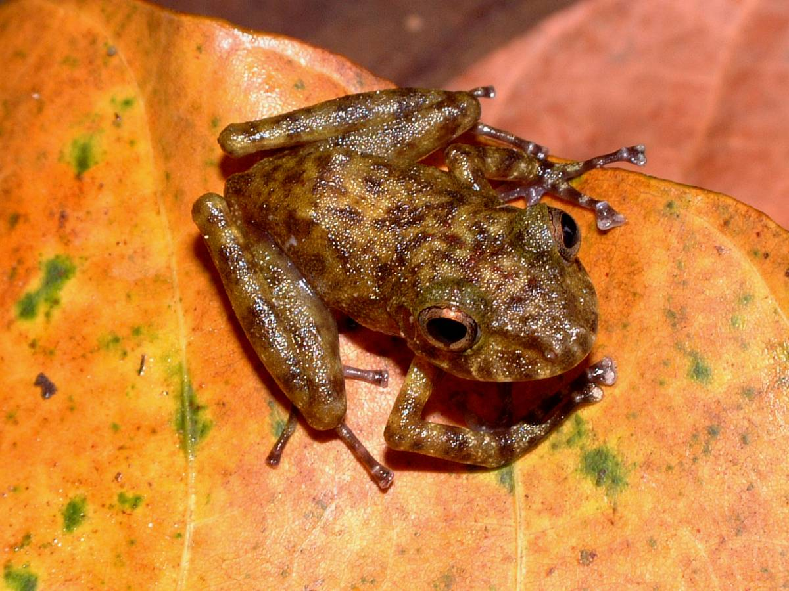

Common Name: Mottled Chirping Frog Native Name:

Scientific Name: Syrrhopus leprus Family: Leptodactylidae

Information: A small, tan to greenish frog that has slender front legs and thick rear legs. A difficult specimen to locate but is usually found on low shrubs at night after a good rain.

Descriptive Characteristics: Usually has mottling all over its Key Characteristics:
back Mottling

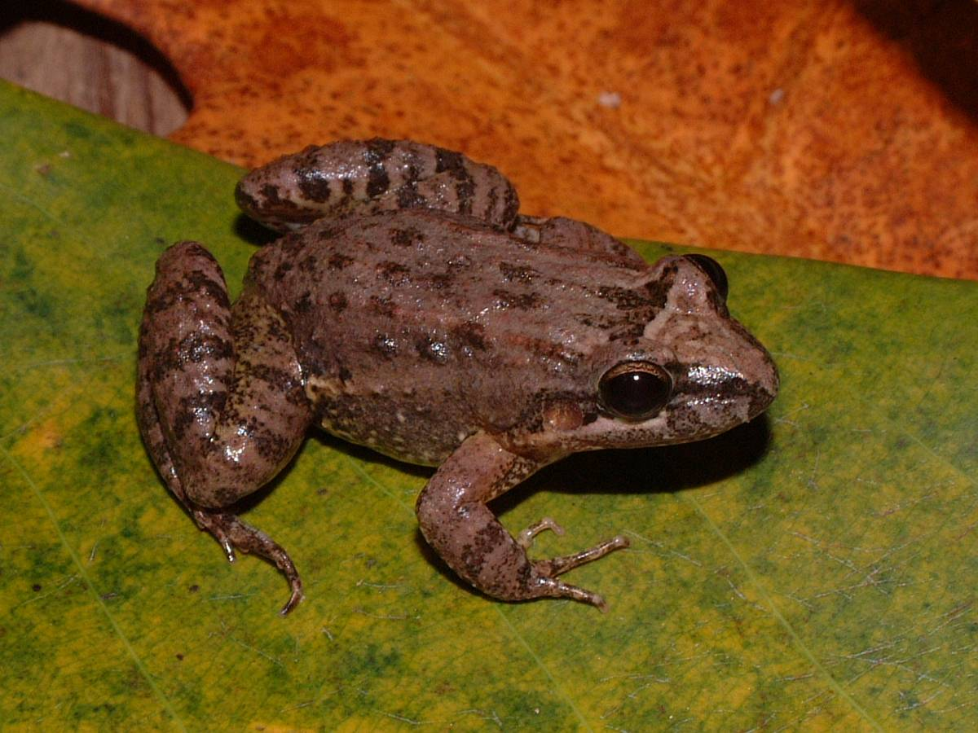

Common Name: Fringe-toed Foamfrog Native Name:

Scientific Name: Leptodactylus melanonotus Family: Leptodactylidae

Information: A small terrestrial frog that is common in virtually all freshwater habitats. Often seen at night after heavy rains. Eggs are deposited into foam nests at the waters edge.

Descriptive Characteristics: Long, thin toes on a stout Key Characteristics:
frog that is grey to brown with black leg stripes and a white Thin toes, no webbing
line under the eye

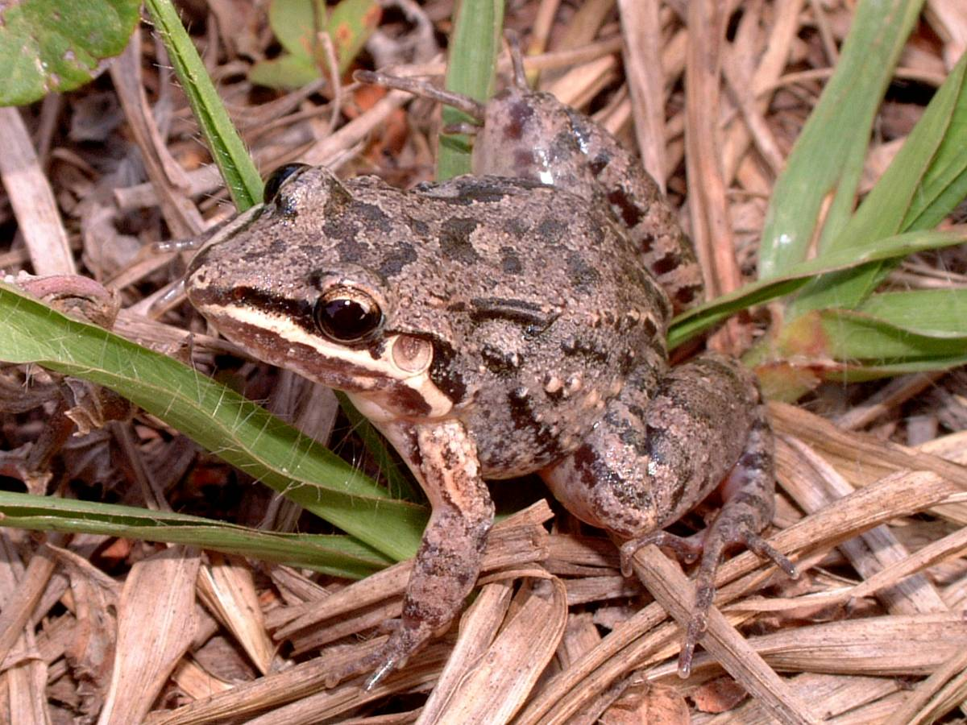

Common Name: White-lipped Foam Frog Native Name:

Scientific Name: Leptodactylus labialis Family: Leptodactylidae

Information: A small, abundant frog that is often found in grass fields. Can also occur in a red-backed morph.

Descriptive Characteristics: Has very thin toes on the Key Characteristics:
rear foot with almost no webbing. Front toes may be a White line on upper
bit expanded, but the rear toes are not. jaw

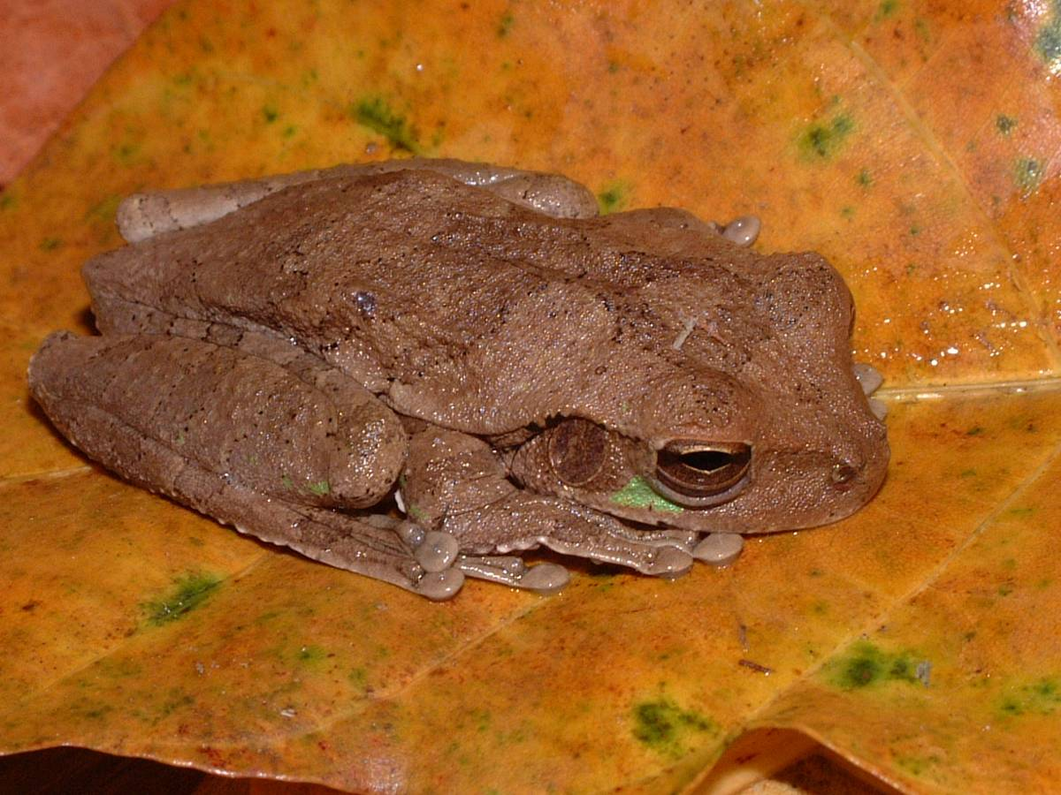

Common Name: Mexican Treefrog Native Name:

Scientific Name: Smilisca baudinii Family: Hylidae

Information: A large, green to brown frog that is rather robust. Very abundant and widespread. Can be found everywhere, from forests to the sides of buildings.

Descriptive Characteristics: Head is broad and flattened. Key Characteristics:
Faint stripes can be seen on the rear legs. Webbed toes, large
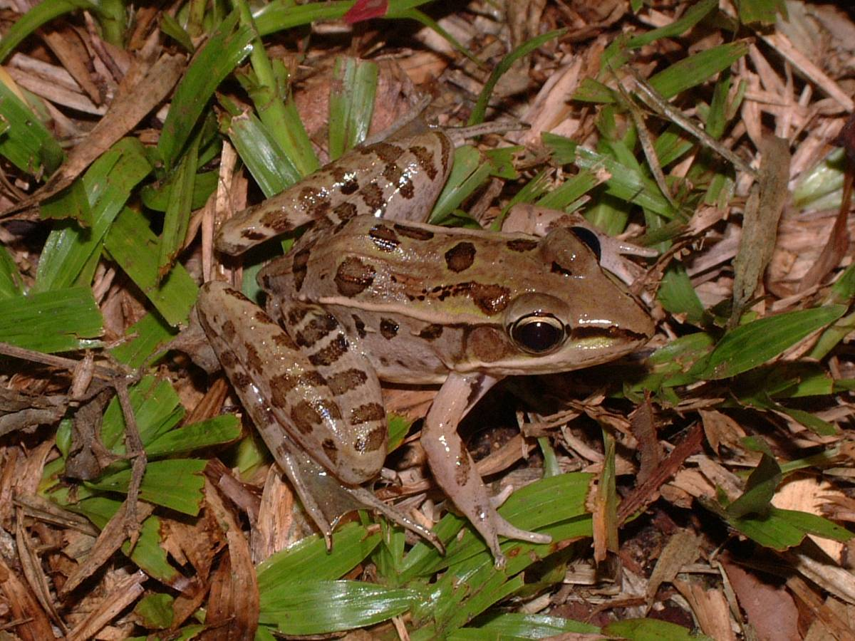

Common Name: Rio Grande Leopard Frog Native Name:

Scientific Name: Rana berlandieri Family: Ranidae

Information: A moderate sized frog usually found near bodies of water. A common frog throughout Belize that can be found during the day or at night.

Descriptive Characteristics: Brown with several circular Key Characteristics:
spots on its back. Rear toes are strongly webbed and dorso- Spots, pointed snout lateral folds are present.

